# Brainstorm

### Before you collaborate

A little bit of preparation goes a long way with this session. Here’s what you need to do to get going.

**10 minutes**

**1**

### Define your problem statement

What problem are you trying to solve? Frame your problem as a How Might We statement. This will be the focus of your brainstorm.

**5 minutes**

**2**

### Brainstorm

Write down any ideas that come to mind that address your problem statement.

**10 minutes**

**3**

### Group ideas

Take turns sharing your ideas while clustering similar or related notes as you go. Once all sticky notes have been grouped, give each cluster a sentence-like label. If a cluster is bigger than six sticky notes, try and see if you and break it up into smaller sub-groups.

**20 minutes**

**4**

### Prioritize

Your team should all be on the same page about what's important moving forward. Place your ideas on this grid to determine which ideas are important and which are feasible.

**20 minutes**

### After you collaborate

You can export the mural as an image or pdf to share with members of your company who might find it helpful.

**Quick add-ons**

# & idea prioritization

Good Battery life

Water & sweat Proof

**PROBLEM**

**How could IOT be used to offer a child safety monitoring and notification system?**

#### Use this template in your own brainstorming sessions so your team can unleash their imagination and start shaping concepts even if you're not sitting in the same room.

1. **Team gathering**

Define who should participate in the session and send an invite. Share relevant information or pre-work ahead.

1. **Set the goal**

Think about the problem you'll be focusing on solving in the brainstorming session.

1. **Learn how to use the facilitation tools**

Use the Facilitation Superpowers to run a happy and

**Vinothini Rajam R**

Child's heart rate, temperature, and pulse are recorded, and an emergency is reported.

Water & sweat Proof

**Sushma A**

## 

Low levels of radiation

Movement of the child is geofenced.

**Tracking Location**

## 

Alerts if the specified range is surpassed

Movement of the child is geofenced.

**Database**

## 

Utilization of cloud services

Secure database

1. **Share the mural**

**Share a view link** to the mural with stakeholders to keep them in the loop about the outcomes of the session.

1. **Export the mural**

Export a copy of the mural as a PNG or PDF to attach to emails, include in slides, or save in your drive.

Create Mobile application

**10 minutes** to prepare

**1 hour** to collaborate

**2-8 people** recommended

productive session.

[**Open article**](https://support.mural.co/en/articles/2113740-facilitation-superpowers)

##### Key rules of brainstorming

Alerts if the specified range is surpassed

To run an smooth and productive session

##### Keep moving forward

**Strategy blueprint**

Define the components of a new idea or strategy.

[**Open the template**](https://app.mural.co/template/e95f612a-f72a-4772-bc48-545aaa04e0c9/984865a6-0a96-4472-a48d-47639307b3ca)

**Customer experience journey map**

Stay in topic. Defer judgment.

Child's heart rate, temperature, and pulse are recorded, and an emergency is reported.

Tracking and updating the whereabouts of the child continuously

When something urgent happens, use satellite calling.

Alerts if the specified range is surpassed

Tracking and updating the whereabouts of the child continuously

Create Mobile application

Accurate sensors to measure heart rate and temperature

Encourage wild ideas. Listen to others.

##### Importance

If each of these

Understand customer needs, motivations, and obstacles for an experience.

[**Open the template**](https://app.mural.co/template/b7114010-3a67-4d63-a51d-6f2cedc9633f/c1b465ab-57af-4624-8faf-ebb312edc0eb)

Child's heart rate, temperature, and pulse are recorded, and an emergency is reported.

When something urgent happens, use satellite calling.

Adaptation to parental mobile devices

Secure database

Go for volume. If possible, be visual.

**Vijayasankari P**

**Prakathi S UI**

**Physical Features**

tasks could get

done without any difficulty or cost, which would have the most positive impact?

**Strengths, weaknesses, opportunities & threats**

Identify strengths, weaknesses, opportunities, and threats (SWOT) to develop a plan.

|  |  |
| --- | --- |
|  |  |
|  |  |

[**Open the template**](https://app.mural.co/template/6a062671-89ee-4b76-9409-2603d8b098be/ca270343-1d54-4952-9d8c-fbc303ffd0f2)

[**Share template feedback**](https://muralco.typeform.com/to/CiqaHVat?typeform-source=app.mural.co)

Good Battery life

Low levels of radiation

Create Mobile application

User friendly application

Secure database

When something urgent happens, use satellite calling.

Comfortable &

easily wearable

Adaptation to parental mobile devices

Low levels of radiation

Utilization of cloud services

Create web Application

User friendly application

Good Battery life

Brilliant UI/ UX Design for Application

Comfortable &

easily wearable

Water & sweat Proof

Comfortable &

easily wearable

[**Share template feedback**](https://muralco.typeform.com/to/CiqaHVat?typeform-source=app.mural.co)

##### Feasibility

Regardless of their importance, which tasks are more feasible than others? (Cost, time, effort, complexity, etc.)

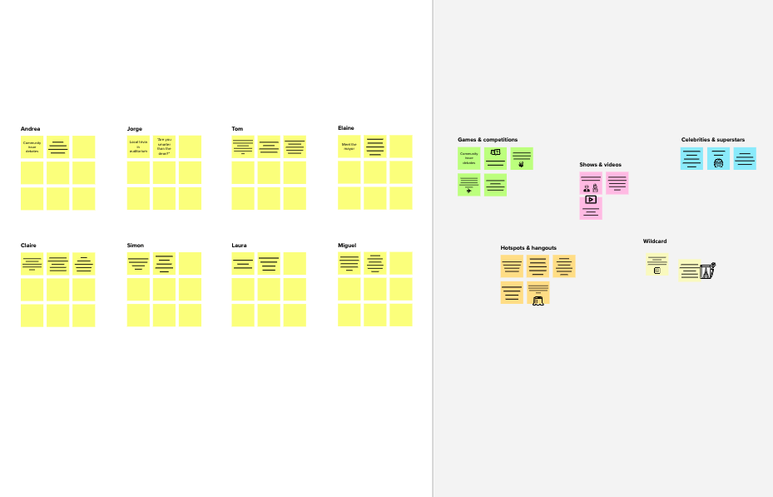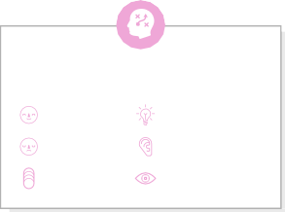

**Template**

**Need some inspiration?**

See a finished version of this template to kickstart your work.

[**Open example**](https://app.mural.co/template/e5a93b7b-49f2-48c9-afd7-a635d860eba6/93f1b98d-b2d2-4695-8e85-7e9c0d2fd9b9)